**A Project Report**

**On**

**"SPORTS SCORESHEET ORGANIZER"**

Submitted in Partial Fulfillment of the Requirement Of

Project-I (BIT106CO)

Of

Bachelor of Information Technology

**Submitted to:**



Purbanchal University

Biratnagar, Nepal

**Submitted by:**

Sagar Upadhyaya (313346)

Shubham Ghimire (313348)

Dhiraj Sapkota (313326)

**KANTIPUT CITY COLLEGE**

Putalisadak, Kathmandu

November 21, 2021

**A Project Report**

**On**

**“SPORTS SCORESHEET ORGANIZER”**

Submitted in Partial Fulfillment of the Requirement Of

Project I-(BIT106CO)

Of

Bachelor of Information Technology

**Submitted to:**

Purbanchal University

Biratnagar, Nepal

**Submitted by:**

Sagar Upadhyaya (313346)

Shubham Ghimire (313348)

Dhiraj Sapkota (313326)

**Project Supervisor**

**Ashim Kc**

**Program Coordinator**

**KANTIPUT CITY COLLEGE**

Putalisadak, Kathmandu

November 21, 2021

**CERTIFICATE OF TOPIC APPROVAL SHEET**

It is here by informed that the topic selected by Sagar Upadhyaya, Shubham Ghimire, and Dhiraj Sapkota of BIT First semester project has been found suitable and as per the credit assigned by Purbanchal University (PU), Biratnagar, Nepal. The Project Committee has approved the following topic and supervisor for the mentioned students. This project has been completed for the prescribed period and the project embodied the result of their investigation conducted during they worked as full-time student of this institution.

Topic Approved: Sports Scoresheet Organizer

_____________________ ______________________

Mr. Saroj Pandey Mr. Ashim Kc

Deputy HOD, Department of Information Technology Project Supervisor

Kantipur City College Kantipur City College

**CERTIFICATE FROM SUPERVISOR**

This is to certify that the project titled “Sports Scoresheet Organizer” submitted by Sagar Upadhyaya, Shubham Ghimire, and Dhiraj Sapkota to the Department of Information Technology, School of Science and Technology at Kantipur City College, Kathmandu, Nepal towards the requirement for Project-I (BIT106CO) is an original work carried out by them under my supervision and guidance.

____________________

Ashim Kc

Department of Information Technology

Kantipur City College

(Project Supervisor)

**ACKNOWLEDGEMENT**

We would like to acknowledge all who have encouraged and inspired us directly or indirectly to complete this project. At first we desire to express our deepest sense of gratitude to Purbanchal University for giving us the opportunity to present ourselves this report within the scheduled time.

We want to thank Kantipur City College for providing this opportunity by approving our project. We are very grateful to our supervisor Mr. Ashim Kc for continuously supporting and guiding us in our project and providing his valuable time to complete our project.

We also are very thankful to Mr Bikash Neupane who was also helpful for providing us the idea to prepare this project and for continuously motivating us to focus towards our project.

We are fortunate enough to get the encouragement and feedback from our teachers and friends. Lastly, many thanks to all the people for their suggestions, feedback and support which was the most in completing our project successfully.

This project has been a wonderful experience where we have learnt and experienced many beneficial things.

With regards

Sagar Upadhyaya

Shubham Ghimire

Dhiraj Sapkota

**ABSTRACT**

Maintaining Scoresheet of the games using software can be the best way to practice for accessing and entering essential data and information required. So, such kind of project is Sports Scoresheet Organizer which we built using the C programming language that can be useful to record or store data regarding the Scoresheet information of the games: cricket and football. Sports Scoresheet Organizer can be used for maintaining such kinds of games detail as it will increase the efficiency and smoothness of the program and help user to enter the data at run time during the games.

This project report on Sports Scoresheet Organizer consists of background and significance of the project with objectives, features and problem solving statement of the project which shows the detail information about the research done about existing system and limitation of them and its working mechanism with proper functionality. And we are hopeful that this project (Sports Scoresheet Organizer) might be helpful for most of the users who desire for maintaining systematic record of the scoresheet of the games (Cricket and Football).

**LIST OF TABLE**

|  |  |  |
| --- | --- | --- |
| **Table no.** | **Table name** | **Page no.** |
| 1 | Team Structure and Role | 11 |
| 2 | Functional Requirement | 15 |
| 3 | Data Structure | 16 |
| 4 | Requirement Gathering Process | 12 |

# **ABBREVATIONS**

* SSO: Sports Scoresheet Organizer
* HDD: Hard Disk Drive
* IDE: Integrated Development Environment
* RAM: Random Access Memory
* GUI: Graphical User Interface

**TABLE OF CONTENT**

**Table of Contents**

**ACKNOWLEDGEMENT5**

**ABSTRACT6**

**LIST OF TABLES7**

**ABBREVATIONS7**

**Chapter 1: Introduction**10

1.1 Project background10

1.2 Project significance10

1.3 Problem solving statements10

1.4 Project objectives11

1.5 Project features11

1.6 Team structure and roles11

**Chapter 2: system Analysis12**

2.1 Literature Review12

2.1.1 Limitation of Existing projects12

2.2 Requirement gathering process12

2.3 Feasibility study13

2.3.1 Technical feasibility13

2.3.2 Economic feasibility 13

2.3.3 Operational feasibility 13

2.3.4 schedule feasibility 13

**Chapter 3: system design14**

3.1 Functional analysis14

3.1.1 Header files15

3.1.2 classes16

3.2 Algorithm16-20

3.3 Flowchart21-24

**Chapter 4: System Development And Implementation25**

4.1 programing platform(Tools and technology used)25

4.1.1 software specification25

4.1.2 Hardware specification25

**Chapter 5: Conclusion and future enhancement26**

5.1 conclusion26

5.2 Future enhancement26

**REFERENCES27**

**APPENDIXES28**

**APPENDIXES** 128

1.1 Main menu28

1.2 admin menu28

1.3 manager menu29

1.4 staff menu29

1.5 customer menu30

1.6 admin login30

1.7 manager login30

1.8 staff login30

1.9 customer login menu30

1.10 customer login30

1.11 customer regestiation30

**APPENDIXES** 232

2.1 Gantt chart32

**CHAPTER 1: INTRODUCTION**

* 1. **Project Background**

Maintaining Scoresheet of the games without using system creates a lot of problem in data entry, data update as well as data access. So, we built up the system that can be best use for maintaining scoresheet of the games. Sports Scoresheet Organizer is the project that is built for the systematic maintenance of the scoresheet during the games i.e. Cricket and Football. For e.g.: this program can create and display the scoresheet which includes the match detail such as total runs, total wickets, names of batsmen and bowlers, overs, extras, etc. in case of cricket. Similarly, different records such as total goals, fowls, saved, assist, time, names of player and their respective position, etc. in case of football.

The interface of this project is quite easy to interact as this project is coded in user understandable form. This system consists of different functions and also has menu options which are easily understandable by the users. As the program name itself describes, it is a system with availability of multiple features where user can create, search, modify, update and view different records of the game.

This system also has a security function so that only authorized individuals can operate it. The above details provide a little background of the system which is the purpose of this report.

* 1. **Project Significance**

This project is mainly concerned with making an application using the C programming language and the main significance of this project is to help understand the use of C programming language and as a medium to make the imagination of any programmer into the reality.

* 1. **Problem Solving Statement**

Sports Scoresheet Organizer provides the platform to the user where they can create, search, modify, update and view different records of the game. This project provides user the ability to create file in order to store different records of football and cricket scoresheet and can search the file records with the help of file code.

* 1. **Project Objectives**
* To provide user the ability to create, modify, search, update and view manager, staff, cinema, movies etc and to book tickets of the movies
* To make it applicable when there is need of cinema booking system
  1. **Project Features**
* Password protection
* Access of details info regarding manager, staff, cinema and movie
* Booking and billing of tickets of movie
* Offline operated
* Easy access in any computer

**1.6 Team Structure and Role**

|  |  |
| --- | --- |
| **Team Members** | **Task Performed** |
| Sagar Upadhyaya | Coding, documentation, design, debugging & research |
| Shubham Ghimire | Logic development, documentation, design, debugging |
| Dhiraj Sapkota | Coding, documentation, debugging, research & analysis |

**CHAPATER 2: SYSTEM ANALYSIS**

**2.1 Literature review**

Creating and Maintaining the Sports Scoresheet in simple paper based format was in practice since early time. But with the change in time and technology the system of record keeping was digitalized and creating and maintaining the records has become much more efficient and more easily accessible.

During our research we found some scoresheet related project that has already been developed. But those project were lacking features like different games detail such as: format of the game, venue, wickets, no of balls, all players record etc. The interface of the project wasn’t user friendly and this system also lacked security function. Likewise, those project didn’t have the feature to edit and view records. Hence, we included all the mentioned features in our program “**Sports Scoresheet Organizer**”.

**2.1.1 Limitation of existing system**

* Can only be operated by single user
* No graphical user interface (GUI)

**2.2 Requirement gathering process**

|  |  |  |  |
| --- | --- | --- | --- |
| **Requirement No.** | **Requirement Name** | **Requirement description** | **Function Number** |
| 1. | password | To make cinema hub secured | 1 |
| 2 | create | To create manager, staff, movie, cinema | 2 |
| 3 | display | To display existing manager, staff, movie, cinema | 3 |
| 3 | Edit | To edit details of manager, staff, movie, cinema | 4 |

**2.3 Feasibility study:**

In a feasible study we performed feasibility analysis of a current system and the proposed system. Feasibility study is done to identify the deficiencies in the current system and find the objective of the proposed system. There are many types of study that needs to be consider but following are the major study we performed while developing this project.

**2.3.1 Technical Feasibility**

Here we analyze the technical aspects of the project. The various technical aspects such as hardware and software were taken into consideration while developing this project.

Further we also make sure that this software is feasible for the person who uses it.

**2.3.2 Economic Feasibility**

Here we deal with the cost benefit of the project. Since this project is developed to meet our academic project, therefore there is no any refund.

**2.3.3 Operational Feasibility**

We develop this project with the minimum specification computer so that it will go long lasting because of low cost and reliable.

The user will enjoy with this system which is easy to understand and operate by few instructions.

**2.3.4 Schedule Feasibility**

In this feasibility study we prepared our planned Gantt chart according to our development model.

**CHAPTER 3: SYSTEM DESIGN**

**3.1 Functional Analysis**

This system contains different functions, header files that helps in running our project. All the header files and functions used in our project are given below along with their characteristics and descriptions:

**3.1.1 Header Files**

|  |  |
| --- | --- |
| **Header file** | **Description** |
| #include<iostream.h> | All standard library functions for file input and output are included on stdio.h |
| #include<conio.h> | All console input/output functions are included in conio.h |
| #include<stdlib.h> |  |
| #include<graphics.h> | All graphical functions are included on graphics.h |
| #include<dos.h> | dos.h header file provide us easy access to use function for date and time. |
| #include<math.h> | math.h contains function for handling different mathematical operation. |
| #include<string.h> | string.h contains function for handling string operations. |
| #include<ctype.h> |  |
| #include<fstream.h> |  |

**3.2.1 classes**

|  |  |
| --- | --- |
| **class** | **Description** |
| Main_menu |  |
| Admin |  |
| Manager |  |
| staff |  |
| customer |  |
| Manager_details |  |
| Staff_details |  |
| Cinema_details |  |
| Customer_details |  |
| Login  shape |  |

**3.4 Algorithm**

Step 1: Start

Step 2: Display Login Interface: choose

1. Admin login
2. Manager login
3. Staff login
4. Customer login
5. Exit

Step 3: if user choose 1 go to step 4

Else if user choose 2 go to step 37

Else if user choose 3 go to step 41

Else if user choose 4 go to step 52

Else terminate the program

Step 4: Display admin registration form if already register then go to

step 5 else register and go to step 5

Step 5: Display login page for admin

Step 6: Input username and password if true then display login successful

and go to step 7 else display Error!! Please try again and goto step 5

Step 7: Display Admin menu choose:

1. Manage manager
2. Manage Staff
3. Manage Cinema
4. Manage Movie
5. Book movie
6. Exit

Step 8: if user choose 1 go to step 9

Else if user choose 2 go to step 16

Else if user choose 3 go to step 23

Else if user choose 4 go to step 30

Else if user choose 5 go to step 61

Else go to previous menu i.e. step 2

Step 9: Display manage manager page choose:

1. Add
2. Remove
3. View
4. Modify
5. Search
6. Back

Step 10: if user choose 1 then display form to add manager and go to step 11

Else if user choose 2 then go to step 12

Else if user choose 3 then go to step 13

Else if user choose 4 then go to step 14

Else if user choose 5 then go to step 15

Else go to previous menu i.e step 9

Step 11: Input Name, user id, Password, position, cinema and phone no and return to step 9

Step 12: Input The manager id to remove particular manager record and press Yes/No and return to step 9

Step 13: Display Manager records like Name, user id, Password, position,

cinema and phone no and return to step 9

Step 14: Input manager id to modify the particular manager record, modify it and return to step 9

Step 15: Input manager id to show the particular manager record and return to step 9

Step 16: Display manage Staff page choose:

1. Add
2. Remove
3. View
4. Modify
5. Search
6. Back

Step 17: if user choose 1 then display form to add staff and go to step 18

Else if user choose 2 then go to step 19

Else if user choose 3 then go to step 20

Else if user choose 4 then go to step 21

Else if user choose 5 then go to step 22

Else go to previous menu i.e step 16

Step 18: Input Name, user id, Password, supervisor, cinema and phone no and return to step 16

Step 19: Input the staff id to remove particular staff record and press Yes/No and return to step 16

Step 20: Display staff records like Name, user id, Password, supervisor,

cinema and phone no and return to step 16

Step 21: Input staff id to modify the particular staff record, modify it and return to step 16

Step 22: Input staff id to show the particular staff record and return to step 16

Step 23: Display manage cinema page choose:

1. Add
2. Remove
3. View
4. Modify
5. Search
6. Back

Step 24: if user choose 1 then display form to add cinema and go to step 25

Else if user choose 2 then go to step 26

Else if user choose 3 then go to step 27

Else if user choose 4 then go to step 28

Else if user choose 5 then go to step 29

Else go to previous menu i.e step 23

Step 25: Input Name, address, manager, no of staff and phone no and return to step 23

Step 26: Input cinema name to remove particular cinema record and press Yes/No and return to step 23

Step 27: Display cinema records like Name, address, manager, no of staff, no of audi and phone no and return to step 23

Step 28: Input cinema name to modify the particular cinema record, modify it and return to step 23

Step 29: Input cinema name to show the particular cinema record and return to step 23

Step 30: Display manage movie page choose:

1. Add
2. Remove
3. View
4. Modify
5. Search
6. Back

Step 31: if user choose 1 then display form to add movie and go to step 32

Else if user choose 2 then go to step 33

Else if user choose 3 then go to step 34

Else if user choose 4 then go to step 35

Else if user choose 5 then go to step 36

Else go to previous menu i.e. step 30

Step 32: Input movie Name, Release-date, major cast, director and time of show and return to step 30

Step 33: Input movie name to remove particular movie record and press Yes/No and return to step 30

Step 34: Display cinema record like Name, Release-date, major cast, director and time of show and return to step 30

Step 35: Input movie name to modify the particular movie record, modify it and return to step 30

Step 36: Input movie name to show the particular movie record

Step 37: Display login page for manager

Step 38: Input username and password if true then display login successful

and go to step 39 else display Error!! Please try again and goto step 37

Step 39: Display manger menu choose:

1. Manage Staff
2. Manage Movie
3. Book movie
4. Exit

Step 40: if user choose 1 go to step 16

Else if user choose 2 go to step 30

Else if user choose 3 go to step 61

Else go to previous menu i.e. step 2

Step 41: Display login page for staff

Step 42: Input username and password if true then display login successful

and go to step 43 else display Error!! Please try again and goto step 41

Step 43: Display staff menu choose:

1. Manage client
2. Book movie
3. Exit

Step 44: if user choose 1 go to step 45

Else if user choose 2 go to step 61

Else go to previous menu i.e step 2

Step 45: Display manage customer page choose:

1. Add
2. Remove
3. View
4. Modify
5. Search
6. Back

Step 46: if user choose 1 then display form to add customer and go to step 47

Else if user choose 2 then go to step 48

Else if user choose 3 then go to step 49

Else if user choose 4 then go to step 50

Else if user choose 5 then go to step 51

Else go to previous menu i.e step 43

Step 47: Input customer Name and password and return to step 45

Step 48: Input customer name to remove customer and press Yes/No and return to step 45

Step 49: Display customer details like name, no of customer and return to step 45

Step 50: Input customer name to modify the customer record and return to step 45

Step 51: Input customer name to show the customer record and return to step 45

Step 52: Display login option for customer choose:

1. Login
2. Register
3. Exit

Step 53: if user choose 1 then display customer login form and go to step 54

Else if user choose 2 then display registration form go to step 55

Else go to previous menu i.e. step 2

Step 54: Input username and password if true then go to step 56 else display Error !! Please

try again and goto step 52

Step 55: display customer register and after registration go to step 54

Step 56: display customer menu: choose

1. Modify pass
2. History
3. Book movie
4. Exit

Step 57: if user choose 1 then display password changing form and go to step 58

Else if user choose 2 then go to step 59

Else if user choose 3 then go to step 61

Else go to previous menu i.e 52

Step 58: Input username, current password, new password and configure password and if login succesful goto step 52 else display Error !! Please try again and goto step 57

Step 59: Display the history of the customer

Step 60: Display the movie list that customer has booked

Step 61: Display :

1. Cinema

2.Movie

3. Time

4.Seats

5. Billing

Step 62: if user choose 1 then go to step 63

Else if user choose 2 then go to step 64

Else if user choose 3 then go to step 65

Else if user choose 4 then go to step 66

Step 63: Input cinema name and go to step 61

Step 64: Input movie name and go to step 61

Step 65 : Input the time of the movie that is available and go to step 61

Step 66: Input the seat no that is available and go to step 61

Step 67 : View the bill and go to step 61

**3.3 Flowchart**

# 

# **Chapter 4: System Development and Implementation**

## 

**4.1 Programing platform (Tools and technologies used)**

**4.4.1 Software Specifications**

Computer software specification we have used for development:

* Operating System: Windows 10 Operating System
* IDE: Dev C++ 5.11 / turbo C++
* Programming Language: C

**4.1.2 Hardware Specifications**

Computer hardware specification we have used for development:

* Processor: core-i7
* RAM: 8GB
* HDD: 1 TB

**CHAPTER 5: CONCLUSION AND FUTURE ENHANCEMENT**

**5.1 Conclusion**

In this documentation we have tried to explained each and every individual's topic clearly as per our project. As this was the first time of doing this kind of project it was difficult to us but we gained new skills which will be helpful to our future project and career. This project was really helpful to us in gaining experience of using c++ programming.

As we know that no any program can be 100% reliable and efficient. So there are also some drawbacks from our system like it cannot perform all the required function as of professional one. It’s simply a program to book movie and manage staffs, manager, cinema and movie. It is actually a user-friendly as it is easy to use by just following the instructions which are appeared on the screen. And actually file input name should have matched the name entered already in the system in order to view the records.

Some of the important things we learned from this project:

1. We learned to use file handling functions where we were able to create, update, view the records in the file.
2. We learned to draw different shapes with the help of graphics.
3. We learned to use both library as well as user defined functions along with their importance.
4. We learned to keep record of the data using classes and so on.

**5.3 Future enhancement**

* Interactive user interface
* GUI based program

**REFERENCES**

Abiral, B(29 June, 2011). Project on c programming. Retrieved July 2, 2021 from <https://www.scribd.com/document/58979208/Project-on-C-programming>

Sasidhar.K(16 Sep, 2014). Mini project on c. Retrieved July 22, 2021 from <https://www.amfastech.com/2014/09/10-miniprojects-inc-with-source-code.html>

Tutorials points (Jan 4,2015). C tutorial. Retrieved Aug 10, 2021 from <https://www.tutorialspoint.com/cprogramming/index.htm>

Jaydeep.D(n.d) 50+ interesting c project. Retrieved Aug 02, 2021 from <https://learnprogramo.com/50-interesting-programming-c-projects-download-with-source-code/>

CodewithCTeam(22 Mar, 2018). 50++ C project. Retrieved Aug 04, 2021 from <https://www.codewithc.com/c-projects-with-source-code/>

**APPENDIXS 1**

* 1. **Main_ Menu**

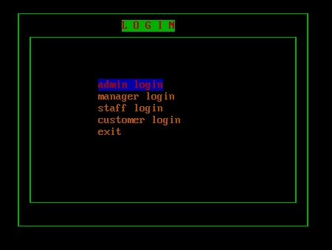

* 1. **Admin menu**

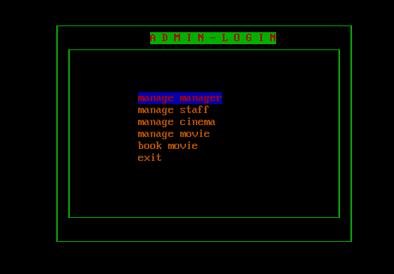

* 1. **Manager menu**

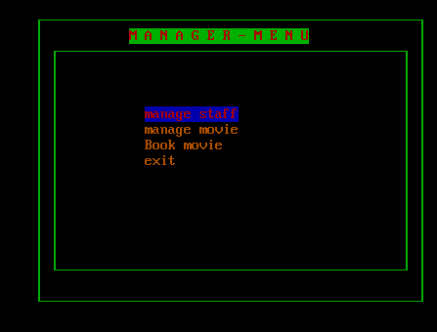

* 1. **Staff menu**

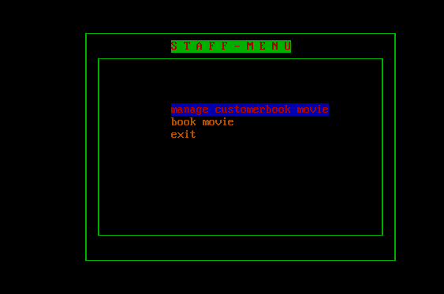

* 1. **Admin login**

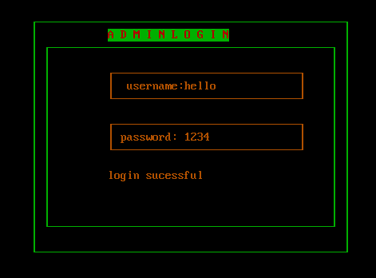

* 1. **Manager login**

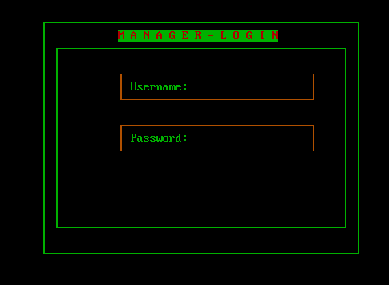

* 1. **Staff login**

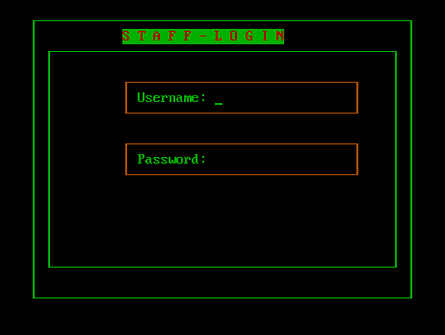

* 1. **Customer login option**

* 1. **Customer login**

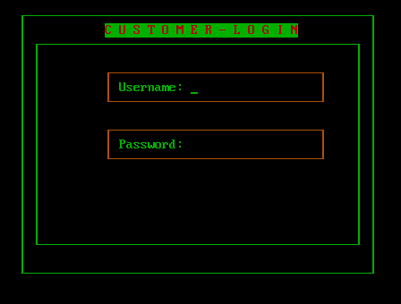

* 1. **Customer registation**

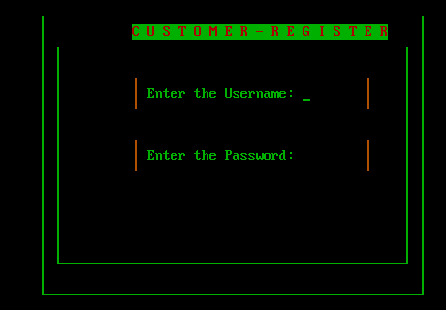

**APPENDIXES 2**

**2.1 Gantt Chart**

|  |  |  |  |  |  |  |
| --- | --- | --- | --- | --- | --- | --- |
| Task Name | 2021 | | | | | |
| **June 1** | **July 1** | **Aug 1** | **Sep 1** | **Oct 1** | **sep 8** |
| Planning |  |  |  |  |  |  |
| Concept submission |  |  |  |  |  |  |
| Research and analysis |  |  |  |  |  |  |
| Design |  |  |  |  |  |  |
| Algorithm/Flowchart |  |  |  |  |  |  |
| Coding |  |  |  |  |  |  |
| Debugging and Testing |  |  |  |  |  |  |
| Documentation |  |  |  |  |  |  |